Day 2

**Module Overview**

* Virtual Machine Planning
* Creating Virtual Machines
* Virtual Machine Availability
* Virtual Machine Extensions
* Lab and Review Questions

**Virtual Machine Planning Overview**

* IaaS Cloud Services
* Planning Checklist
* Location and Pricing
* Virtual Machine Sizing
* Virtual Machine Disks
* Storage Options
* Supported Operating Systems

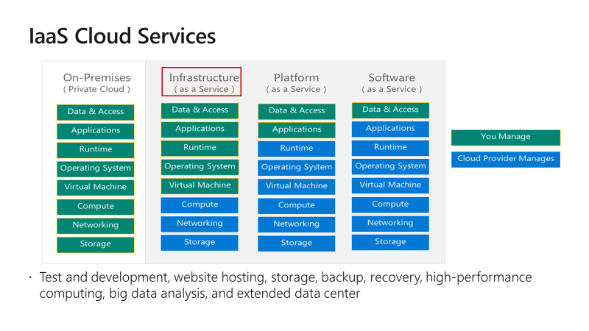

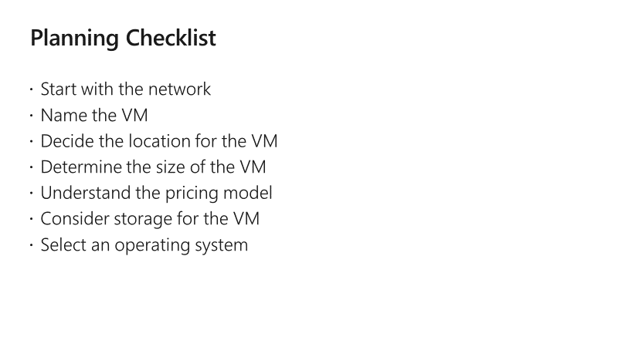

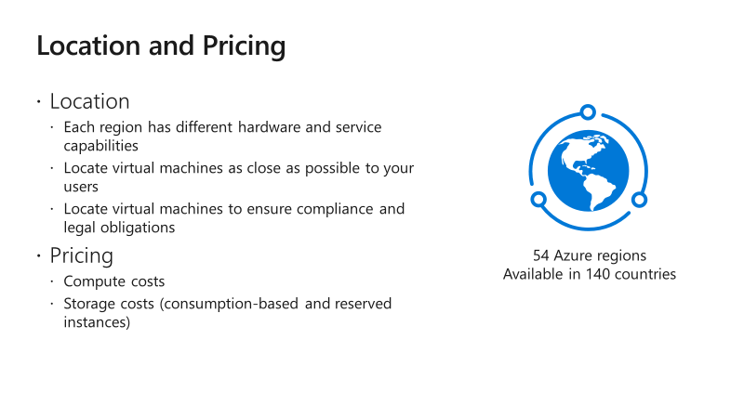

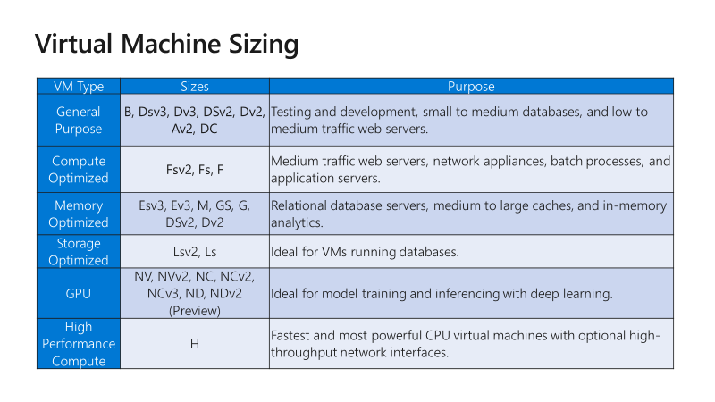

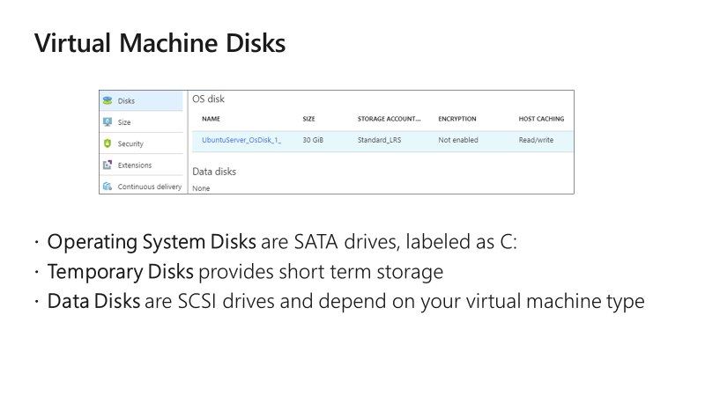

**Storage Options**

* **Premium storage offers high-performance, low-latency SSD disk support**
* **Use premium storage for virtual machines with input/output (I/O)-intensive workloads**
* **Two types of disks: Unmanaged and Managed**
  + **Unmanaged disks require you to manage the storage accounts and VHDs**
  + **Managed disks are maintained by Azure (recommended)**

**Supported Operating Systems**

* Windows Server includes many common products, requires a license, doesn’t support OS upgrades
* Linux distributions are supported, upgrade of the OS is supported

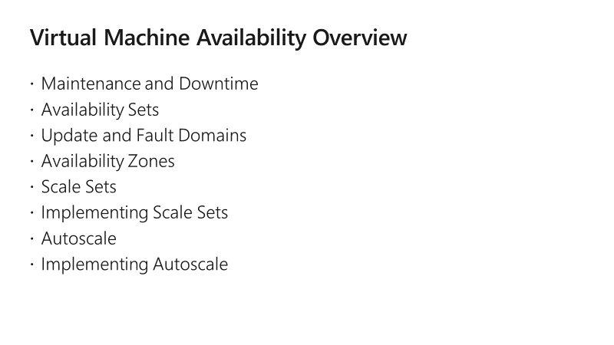

**Maintenance vs. Downtime**

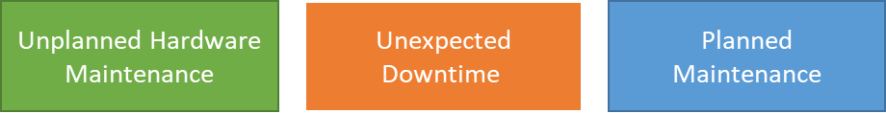

* When the platform predicts a failure, it will issue an **unplanned hardware maintenance** event. Action: Live migration.
* **Unexpected Downtime** is when a virtual machine fails unexpectedly. Action: Automatically migrate (heal).
* **Planned Maintenance** events are periodic updates made to the Azure platform. Action: No action.

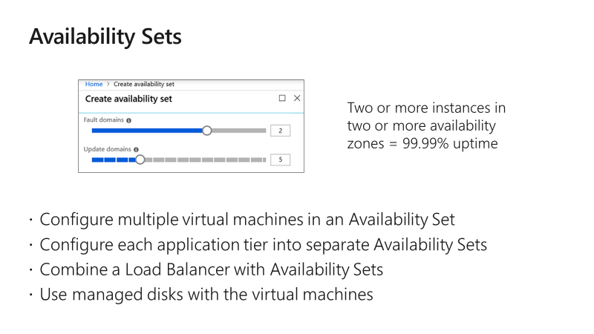

**Update and Fault Domains**

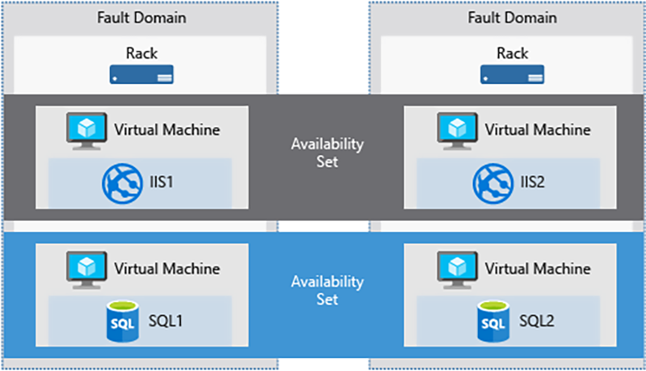

* **Update domains** lets Azure to perform incremental or rolling upgrades across a deployment.  During planned maintenance, only one update domain is rebooted at a time.
* **Fault Domains** are a group of virtual machines that share a common set of hardware, switches, that share a single point of failure.  VMs in an availability set are placed in at least two fault domains.

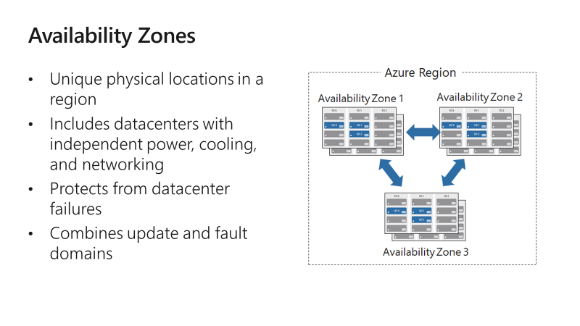

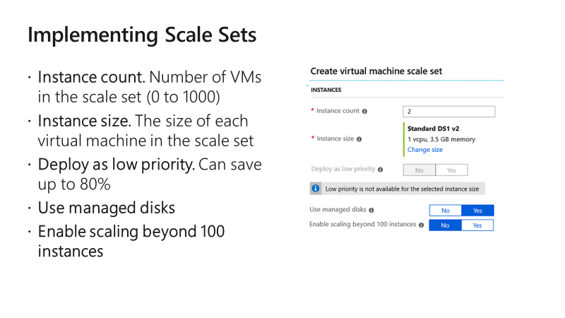

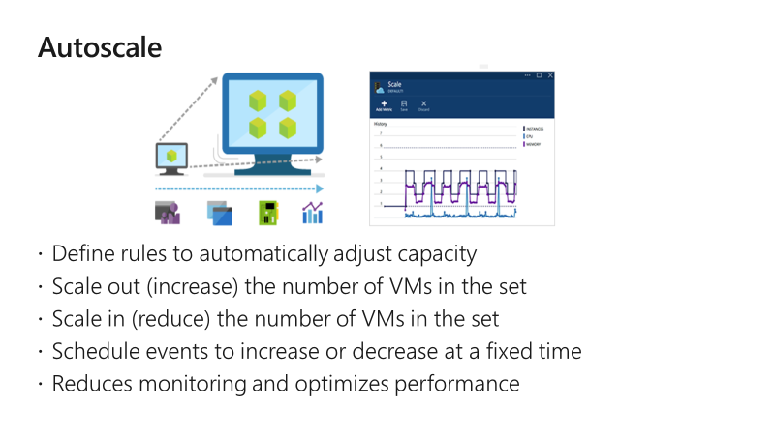

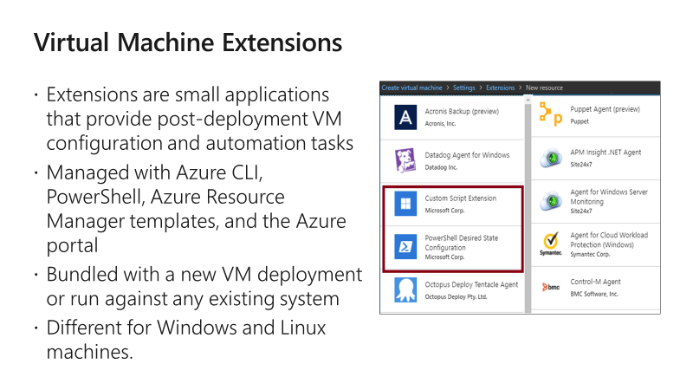

For more information, you can see:

Virtual machine extensions and features for Windows - <https://docs.microsoft.com/en-us/azure/virtual-machines/extensions/features-windows?toc=%2Fazure%2Fvirtual-machines%2Fwindows%2Ftoc.json>

Virtual machine extensions and features for Linux - <https://docs.microsoft.com/en-us/azure/virtual-machines/extensions/features-linux>